## R1:SP2: Story 3: Insert data into staging tables

In Spring 2, as a Developer, I want to write ETL components that will insert 1003 mortgage application input data from various sources into staging database. So that I can validate that data for any errors.

**Complete R1:SP2: Story 2** Task on Basecamp, where you must provide detailed descriptive updates and screenshots to the specific task.

Started by loading the Excel files. Created a dataflow with transformations to source the data and ended up loading to the staging table as depicted in the screenshots below

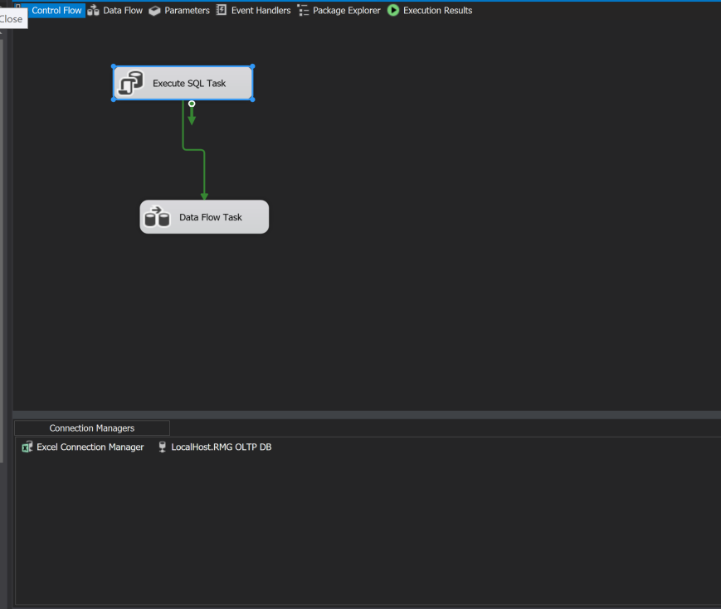

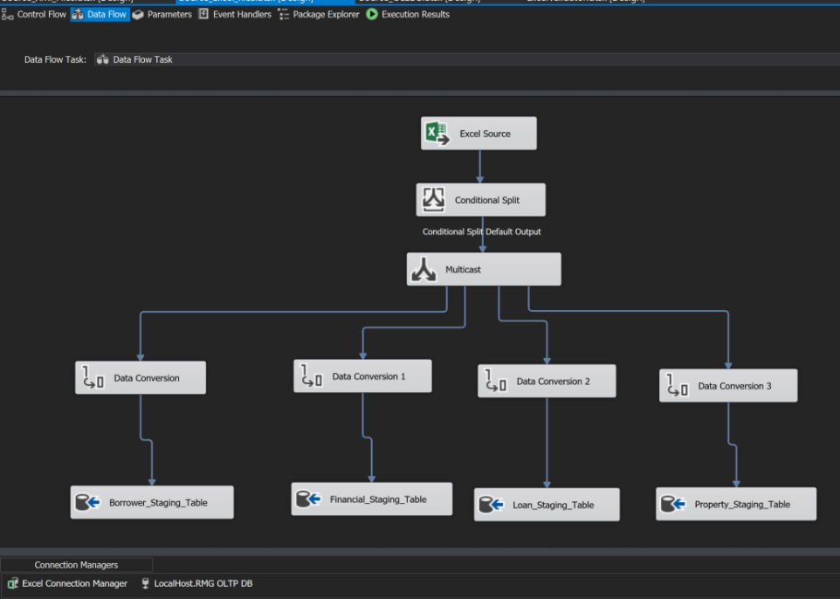

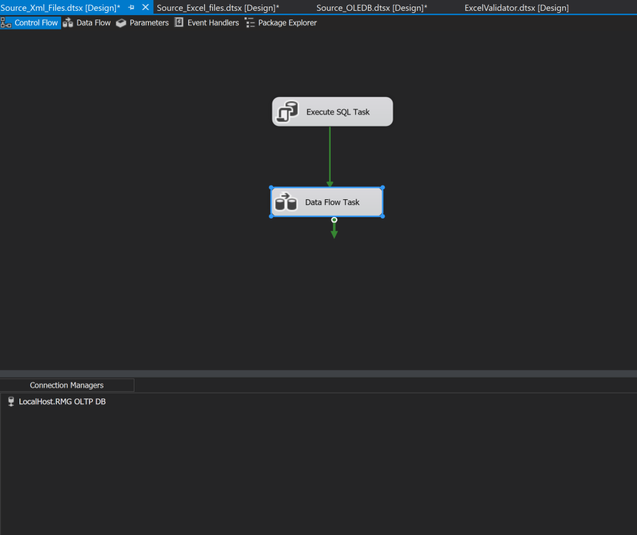

Repeated the same, but this time using XML files and sourcing using XML source transformation. Loaded the data to the staging table after doing data conversion to make sure the columns and data types match as depicted in the screenshots below.

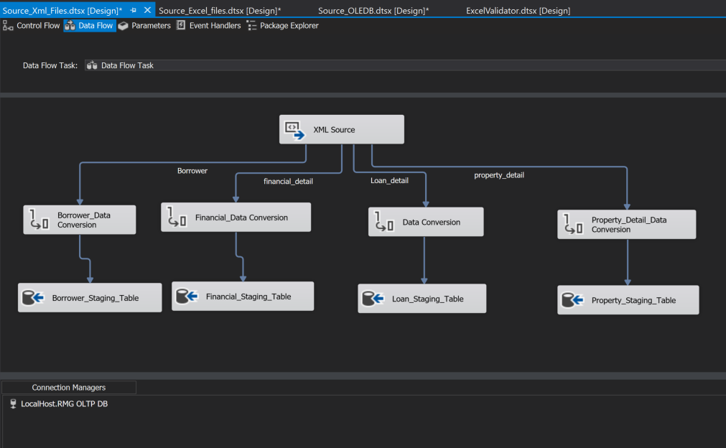

The final scenario involved loading OLEDB files. This time we moved tables from one database to another. Used the OLEdb source transformation and destination to facilitate the loading as shown below.

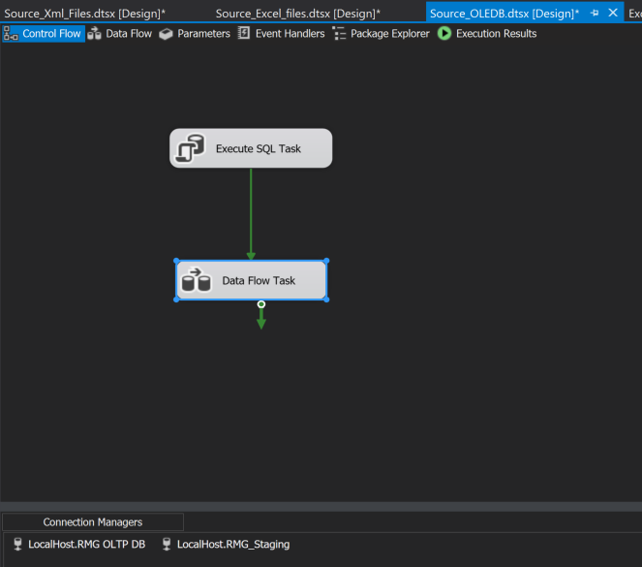

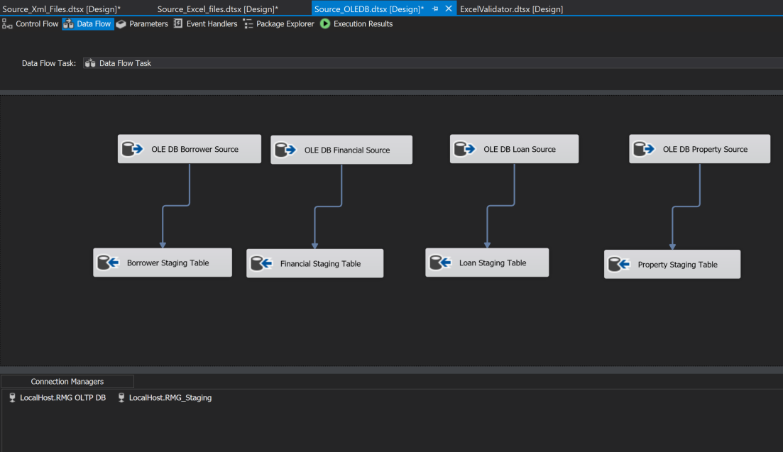

Below are the Staging tables after running queries, and verifying that the transformation has gone through.

